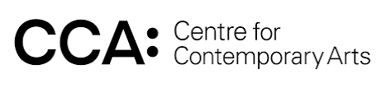
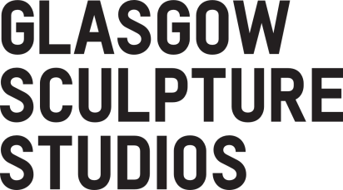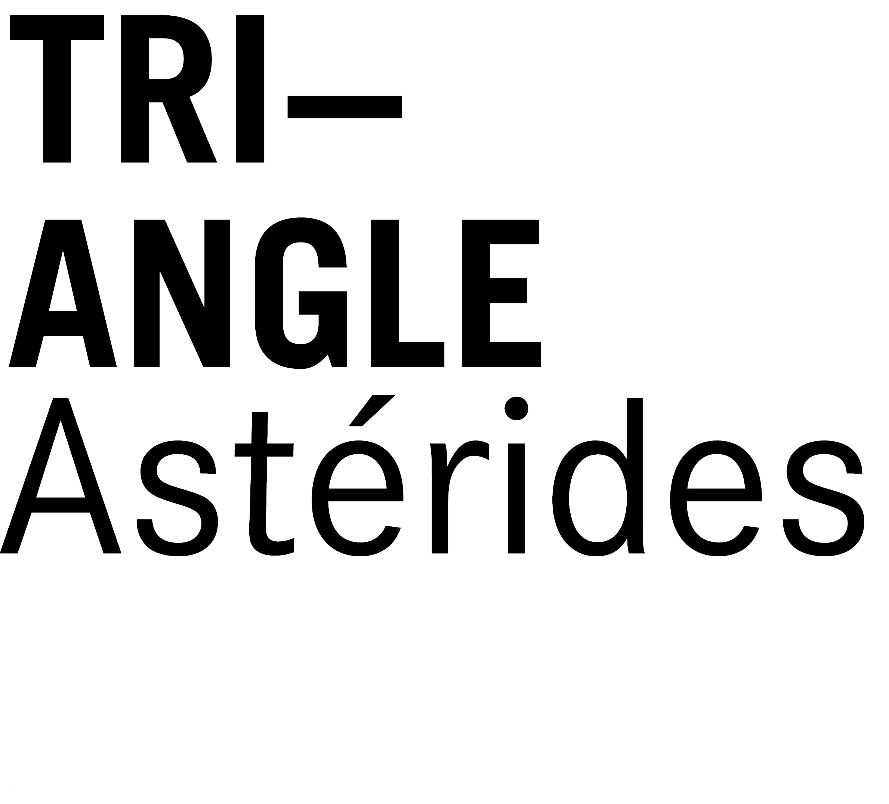

Residency with Glasgow Sculpture Studios in partnership with the Centre for Contemporary Arts

Open call for applications

Dyslexia-friendly version

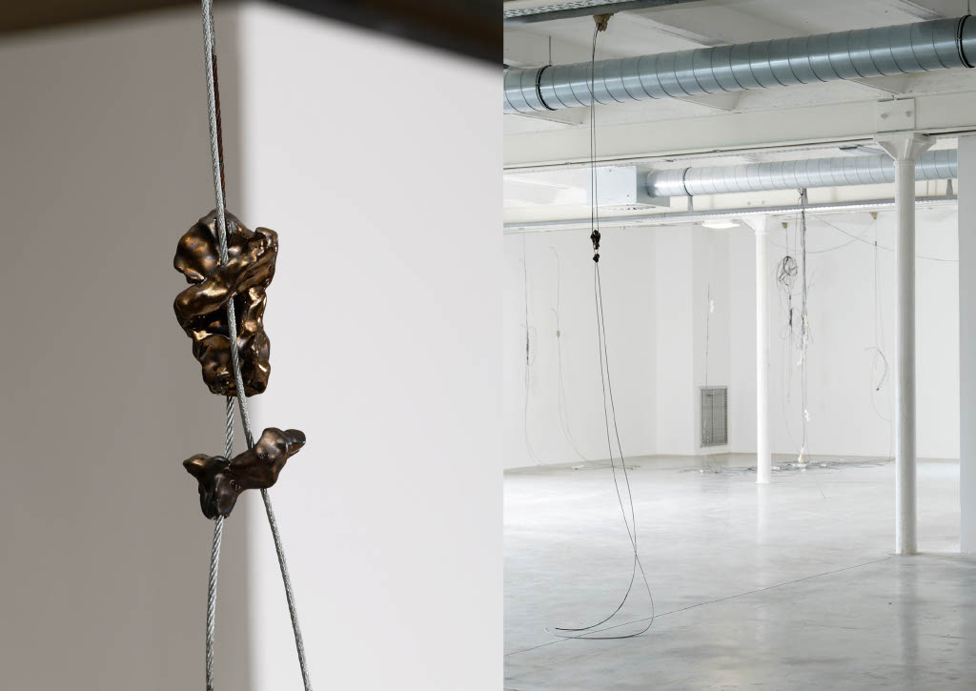

Grow | Aurilian
JAIMES (detail), Triangle - Astérides, centre d’art contemporain d’intérêt national, Marseille
Developed on Residency at GSS + CCA 2022
Photos | Aurélien Mole
About the Exchange

In 2022 Glasgow Sculpture Studios (GSS) and Triangle-Astérides were celebrating the 10th anniversary of their Residency Exchange programme.

Established in 2012, the residency exchange is designed for artists at a pivotal point in their career who have not had major institutional support or the opportunity to develop work abroad. The programme enables Glasgow-based artists and creative practitioners to work, share practice, and learn new skills in France, while facilitating the reciprocal experience for artists based in Marseille to travel to Glasgow and experience the cultural landscape of Scotland.

The partnership between GSS and Triangle-Astérides developed from Glasgow and Marseille’s designation as twin cities in 2006. Both organisations have a history of making culture a centrepiece of life within their cities. Based in former industrial hubs, GSS and Triangle-Astérides share similar objectives, challenges, and working contexts. Both organisations underpin the creative communities of their respective cities through nurturing a supportive and diverse artistic community and providing access to access to artist studios, high-quality production facilities, and cultural networks.

As we move into what we hope will be another decade of the Residency Exchange Programme, we have been reflecting on the work of this programme to date and how we could strengthen it moving forward. It feels prescient at this moment in time to formalise the Centre for Contemporary Art (CCA) as partners in the project. The CCA team have long been a supporter of this programme in a variety of ways; through studio visits, in-kind support, and working with the incoming artists from Marseille to present public outcomes from their residency as part of CCA’s Open Source Programme, so it felt important to acknowledge and embed this support in how the exchange programme moves forward.

As organisations, GSS and CCA complement each other well; with GSS able to offer the space and resources to make work, and CCA offering the space and means to share work in addition to offering their Artist Flat as accommodation. Through working in partnership and combining our skills, resources, and expertise as organisations we’re able to provide an enhanced offer to artists from Marseille that will ensure they are well positioned to make the most of creative ecology of Glasgow.

The Opportunity

The residency period will be April – June 2023, we will negotiate the exact dates with the selected artist.

The selected artist will receive the following;

- Private accommodation in the CCA’s Artist Flat
- Private studio space at GSS with 24-hour access
- Access to specialist production facilities at GSS (including wood, metal, ceramics, resin, and plaster)
- Studio visits and support from the GSS + CCA teams to build networks in Glasgow
- Opportunities to share research and/or outcomes from the residency in collaboration with project partners, depending on what it most useful for the artist.
- A production fee of £1000 and access to dedicated technical support from GSS’ technical team
- A stipend of £1000
- An additional budget is available as a contribution towards individual access requirements

Triangle-Astérides would like to invite applications for participation in this residency supported by Glasgow Sculpture Studios in partnership with the Centre for Contemporary Art.

Application criteria

To apply for this residency, you must meet the following criteria:
- You live and work in Marseille full-time;
- You are a practising artist with a demonstrable desire to explore and expand your practice in contemporary sculpture;
- You have not previously received major institutional support or the opportunity to develop work abroad;
- Please be aware you will be working in English-speaking environments so please bear that in mind when making your application.

Residency outcomes

While there is no expectation for material outcomes during the residency, applicants are expected to meet the following outcomes:
- You will make use of workshop facilities at Glasgow Sculpture Studios during course of the residency;
- You will make use of studio provided at Glasgow Sculpture Studios during course of the residency;
- You will meet with the team at GSS and CCA at regular intervals during course of the residency;
- You will participate in evaluation and reflection after completion of the residency.

How to Apply

Applications should be submitted in English Forms via Google Forms using the link below, and comprise of the following:

https://forms.gle/XvKiBB5BpUpEKbKv8

- Your contact details (Name, Address & Postcode, Telephone No, Email)
- Statement outlining your artistic practice (2000 characters)
- A statement (4000 characters) outlining:
- How this opportunity with Glasgow Sculpture Studios and the Centre for Contemporary Arts would enable you to develop your artistic practice
- How you would take advantage of the opportunity to connect with other artists and creative professionals in Glasgow
- 8-10 images, or up to 3 YouTube or Vimeo links to works that you feel best articulate your practice and best support your application. Please also include a short description (title, medium, date, etc) and/or contextual information for each image.
- Artist CV (2 A4 pages maximum)

** We are happy to accept applications in the following alternative formats: Microsoft Word document, pdf, video (no longer than 5 minutes), audio (no longer than 5 minutes). Applications submitted via an alternative format should follow the criteria outlined above under ‘How to Apply’ **

The deadline for applications is Monday 13th February 2023 at 5pm. Please note, late applications will not be considered.

Applications completed in an alternate format should be emailed to contact@trianglefrance.org

If you have any further questions or require any assistance with your application, please contact Marie de Gaulejac at residence@trianglefrance.org

About Glasgow Sculpture Studios

Glasgow Sculpture Studios is home to a vibrant community of artists working in contemporary sculptural practice.
We are the largest art production facility in Scotland, with specialist workshops in metalwork, woodwork, plaster, resin, ceramics and digital fabrication. We also provide studio space for artists working in these media and more, exploring what sculpture means today.
We have a technical team who provide support to workshop users and we run a specialist fabrication service, making work for a variety of clients in the arts, architecture and design.
Access is at the heart of everything we do. As well as providing affordable access to specialist skills and production space for professional artists and makers, we share our facilities and creative and technical skills with wider groups of people through our learning and engagement programme.
We build and strengthen relationships between our artists, our communities, and our local partners and aim to provide services that are meaningful, relevant and responsive to the needs of all of our users.
We are located at the Whisky Bond on the banks of the Forth and Clyde Canal. As the anchor tenant in the building and one of the first arts organisations to move into the area we continue to play an important role in developing this vibrant creative industries hub in North Glasgow. We are active members of the Canal Co-operative, a network of local organisations established to work collectively to unlock the potential of the Glasgow Canal area and create a vibrant neighbourhood for people to live, work and visit.
GSS also has strong links with similar organisations across the country, and we are a member of Scotland’s Workshops.

About The Centre for Contemporary Arts

The Centre for Contemporary Arts, on Glasgow’s Sauchiehall Street, has hosted visual art, film, performance, festivals and literature since 1992. Previously home to The Third Eye Centre, the building is steeped in history and the organisation has played a key role in the cultural life of the city for decades. CCA presents national and international contemporary art in our gallery space, as well as commissioning and hosting new projects in our online space, CCA Annex, and providing the Intermedia gallery space for emerging artists. CCA hosts cultural events year-round on an open source model, sharing our building and resources with artists, individuals, and organisations to create a citizen-led programme. CCA is also home to Glasgow Seed Library, an extensive Archive and the Creative Lab, a space to provide residencies for creators.

CCA are committed to supporting artists to develop new work. We offer a programme of residencies in our Creative Lab and other spaces at CCA, as well as the use of our Artist Flat. CCA has an artist’s flat on the third floor overlooking Scott Street. It is a small space but allows us to host residencies with minimal accommodation costs. Creative Lab residents coming from further afield can often use this space.

