Accessibility Guide
13 September 2021

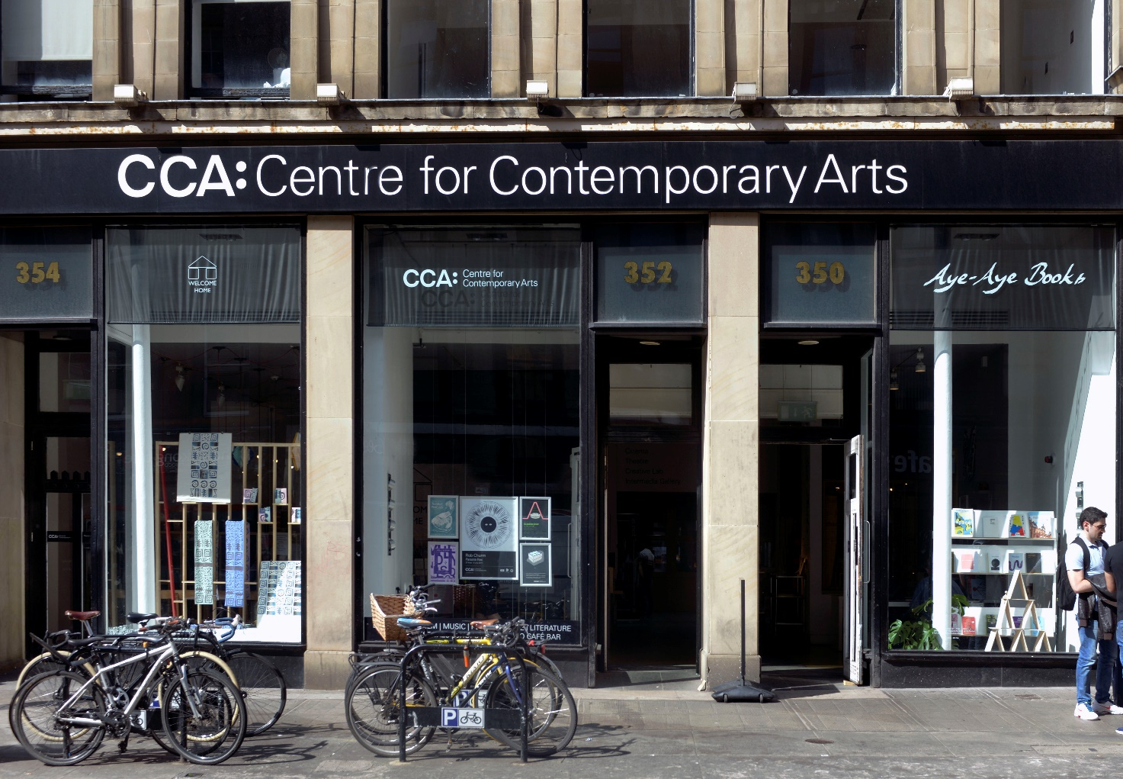

350 Sauchiehall Street
Glasgow, G2 3JD
Tel: 0141 352 4900
Email: gen@cca-glasgow.com
Website: www.cca-glasgow.com
Tue-Thu: 11am-10.30pm
Fri-Sat: 11am-12midnight
Mon & Sun: Closed
Grid ref: NS 58250 65976
Contents

Coronavirus Update p3

About us p4

Getting here p6

Box Office & Foyer p9

Lift Access p11

Ground Floor p12
Gallery p14
Cinema p15
Reading Library p16

First Floor p17
Seed Library p19
Theatre p20
Electron Club & Archive p21
Creative Lab p22

Second Floor p23
Intermedia Gallery p24
Clubroom p25

Toilets & Baby Changing Facilities p26
Saramago Café Bar & Terrace Bar p30
Shops: Welcome Home & Aye-Aye Books p32

Additional Information p33
Future Plans p34

Covid-19 Update

We are working to open our building and maintain a safe and accessible space for everyone. The following changes are particularly relevant for visitors with access requirements

- Hand sanitiser is available in the foyer at the Sauchiehall Street entrance. Sanitiser can be accessed using a foot pump station or alternatively at a low level accessible counter for anyone not able to operate the foot pump.
- We ask that masks be worn when moving around CCA in all public spaces. We recognise that not everyone can wear a face covering and will not ask anyone to present evidence of their exemption.
- We are encouraging anyone who does not need to use the lift to make use of the stairs. If the lift is used, hands should be sanitised before entering and the buttons and hand rail should be cleaned after use with the wipes provided.
- The ground floor toilets and baby change facilities will be for the exclusive use of any customers with accessibility requirements or adults who need to change a baby.
- Our Scott Street entrance will remain closed.

About us

Welcome to CCA.

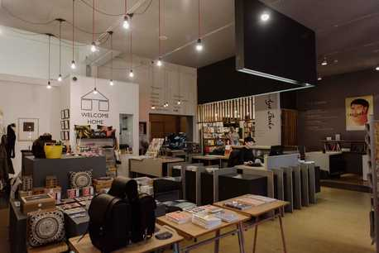
Situated on Sauchiehall Street in Glasgow city centre, CCA is a hub for arts events, cultural organisations and artists. Alongside CCA's visual arts programme of exhibitions, artists' events and residencies, the venue is host to a range of festivals, creative organisations and arts groups who bring their own events to CCA through our open-source approach to programming. At the heart of all our activities is the desire to work with artists, commission new projects and present them to the widest possible audience. CCA also produces a range of artist residencies, both in the venue and internationally.

View of the foyer and Box Office from Welcome Home

The building comprises three floors and is situated on the corner of Sauchiehall Street and Scott Street. The ground floor includes a foyer with a box office, Duty Managers' office, two shops, a cafe bar, gallery, cinema, accessible toilets and lift access to the first and second floors. The first floor has the theatre, Creative Lab, accessible toilets and Terrace Bar. The second floor has Intermedia Gallery and the Clubroom meeting space.

A comprehensive Virtual Tour of the building can be viewed via our website.

We aim to make the building as accessible as possible but if you feel that you might need some additional help, please get in touch in advance or ask a member of staff on arrival. We're open to feedback and would welcome your ideas on any improvements we could make.
Getting here
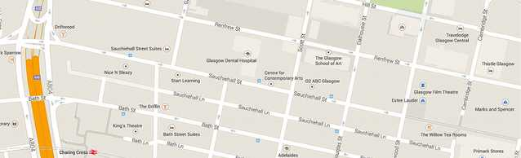
Map

- Current timetables and public transport information can be found on www.travelinescotland.com

- The nearest bus stop to CCA is currently located outside the O2 ABC building just before the corner of Dalhousie Street. First Bus services 3, 4/4A, 18 and 19, amongst others, stop (coming from the west end of the city) here. Buses from the city centre and south side (First Bus services 3, 4/4A, 18 and 19) stop on Bath Street, just before the King's Theatre - a three minute journey with two level crossings from CCA. The 3 and 4/4A also stop at Hope Street by Glasgow Central train station before continuing to Bath Street.

- As part of the renovations of Sauchiehall Street, a new cycle lane has been developed, there are crossing marked at the corner of Sauchiehall Street and Scott Street.

- The nearest train station is Charing Cross, which is about five minutes journey from CCA. Exit the station and turn right for ramp and stair access, and travel round the hotel to the right, and then left to Bath Street along level paving. Turn right and travel along Bath Street, using dropped kerb crossings at Elmbank Street and Holland Street and up a small incline before crossing the road at a dropped kerb crossing with lights before Pitt Street. Travel along the left side of Pitt Street towards Sauchiehall Street for a dropped kerb crossing over Sauchiehall Lane. Use the dropped kerb crossing at the end of Pitt Street to reach CCA. Alternative routes to Sauchiehall Street are available via Elmbank Street and Holland Street, though there are non-flat crossings along these routes.

- The closest Underground station is Cowcaddens, which is around five-ten minutes journey from CCA. From the station, exit right and go through the underpass. Turn left up a steep incline with handrails on either side, then turn right and travel along Cambridge Street towards Sauchiehall Street. There are two crossings with dropped kerbs on this route, the first without lights and the second with. Turn right on Sauchiehall Street and travel up a small incline. Crossing Blythswood Street, Douglas Street and Pitt Street on the opposite side of the road from CCA offers the flattest and best paved crossings. Use the dropped kerb crossing by Pitt Street to reach CCA.

- There is limited on-street metered parking in the surrounding area.

- There are two blue-badge parking spaces available on Pitt Street at the junction with Sauchiehall Street, which are in view of CCA.

- All vehicles used by Glasgow Taxis are wheelchair accessible, please call 0141 429 7070 to book.

- The nearest multi-story car park is City Parking at Charing Cross (https://glasgow.gov.uk/index.aspx?articleid=27165). There are seven disabled bays at Charing Cross car park – all located on ground level. This is a barrier car park and charges apply to all vehicles at all times. This car park is ticketed, paid parking. There is lift access in the car park.

- There is a level crossing on the corner of Sauchiehall Street and Scott Street if approaching from the centre of town; there is also a dropped kerb at the Sauchiehall Street pedestrian crossing adjacent to CCA.

- The main door is at pavement level on Sauchiehall Street. There are two non-automatic doors at the entrance measuring 90cm / 35.5 inches wide. One door opens inwards to the building and the other opens outwards onto Sauchiehall Street.

- There is also an entrance on Scott Street, located off a steep hill with nine steps to the door. There are two non-automatic exterior doors, each measuring 85cm / 33.5 inches wide, and the two interior doors are 80cm / 31.5 inches wide. For level access, please go to Sauchiehall Street.

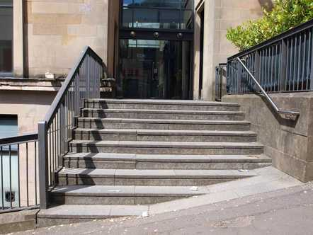
Stairway to entrance from Scott Street

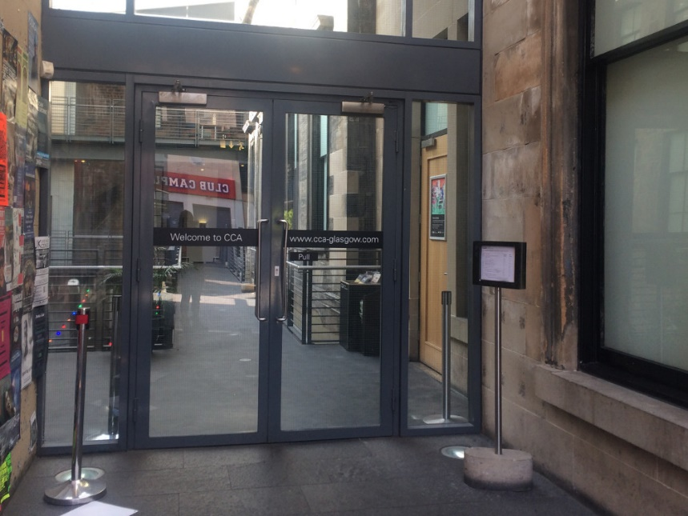
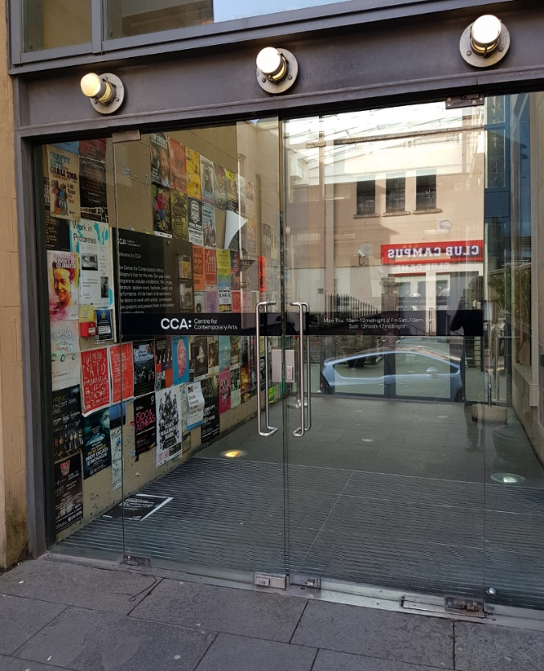
Entrance doorways from Scott Street: Exterior (L) and Interior (R)

Box Office & Foyer

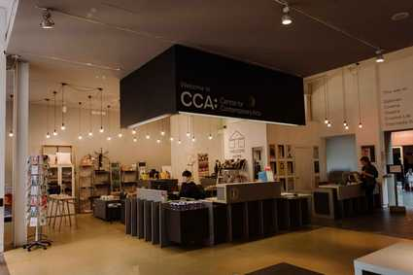
Box Office

- From 10am to 5pm, Tuesday - Saturday, Box Office staff will be available to provide assistance as required.

- The box office is located at the entrance in the main foyer reception; it is an open desk with no glass.

- There is a lowered section of the desk and a hearing loop at reception.

- We provide a complimentary ticket to events for an accompanying carer.

- You can contact CCA via Contact Scotland BSL – Scotland’s British Sign Language Interpreting Video Relay Service – for all enquiries.

- There are three tables with bench seating available for general public use. This area is not licensed, but you are welcome to use the tables for refreshments, meetings or rest.

- The CCA brochure and Saramago menu are both available in large print format from the CCA box office.

- Venue maps are available in the foyer, and a large print version is available from box office. You are welcome to take these throughout the building.
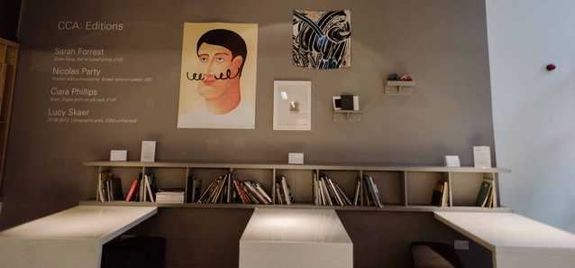
Seating available in the foyer

- There are two shops - Aye-Aye Books and Welcome Home - located in the foyer.

- Welcome Home is currently closed for refurbishment and will reopen in early October 2021.

- Aye-Aye Books opening hours are Thursday – Saturday, 11am – 6pm.

- The corridor in Welcome Home is 80cm / 31.5 inches in width, and in Aye-Aye Books, the corridor is 80cm / 31.5 inches in width. During opening hours, staff can assist you with access to items that are on high shelves or in non-accessible areas of the shops.

- The area is well-lit with natural daylight and overhead bulb lighting.

- The foyer area, atrium and bars can be noisy when the building is busy.

- The floor is a mix of cement and tiles and there is a clear level floor access to the main atrium (containing the Cafe, Gallery, Cinema, toilets and lift) which measures 274cm / 108 inches in width.
- Noise levels vary throughout the building. There is background music in the café all day and evening, and some events can be very busy. Please ask a member of staff if you would like advice on a quieter space during your visit.

- Noise cancelling headphones and earplugs are available from the duty manager on request, please do approach a member of staff if you would like to use the headphones.

- We have a box of sensory materials and toys for anyone who requires them. Please ask the Duty Manager for these.

Lift Access

- The lift provides access to the ground, first and second floors of CCA, covering all public areas.

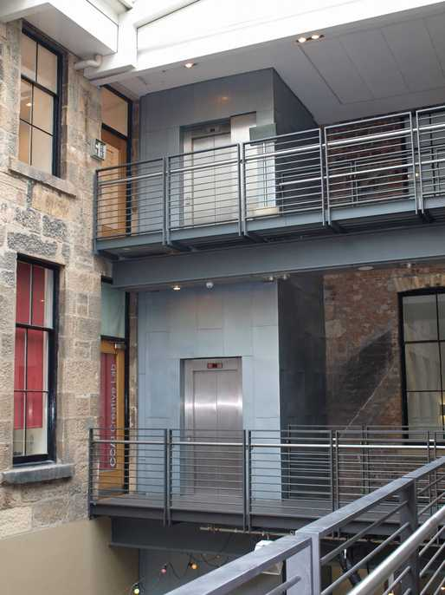
- The doors of the lift are 80cm / 31.5 inches wide. The lift is 110cm / 43 inches wide by 140cm / 55 inches deep.

Lift between first and second floor
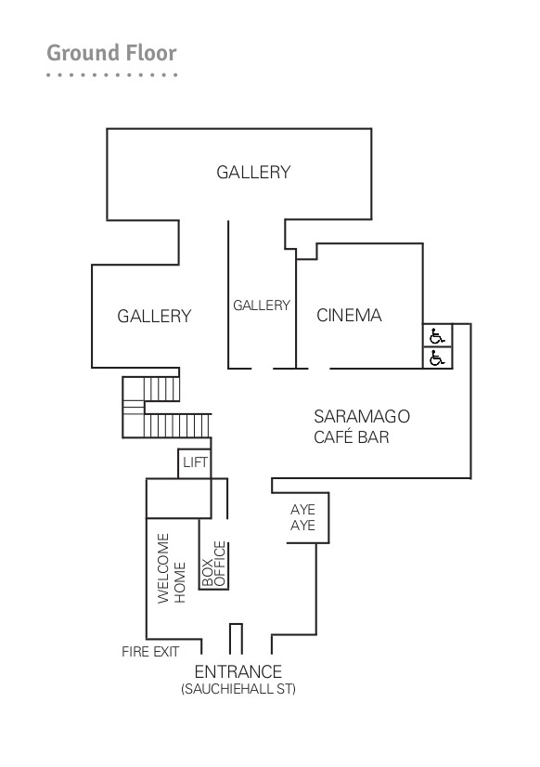

CCA Ground Floor

- CCA is situated across three floors of a historic building at 350 Sauchiehall Street, Glasgow.

- The ground floor comprises the CCA box office, foyer, Welcome Home and Aye-Aye Books shops, the Reading Library, Saramago Café Bar, a 74-seat cinema and our gallery space.

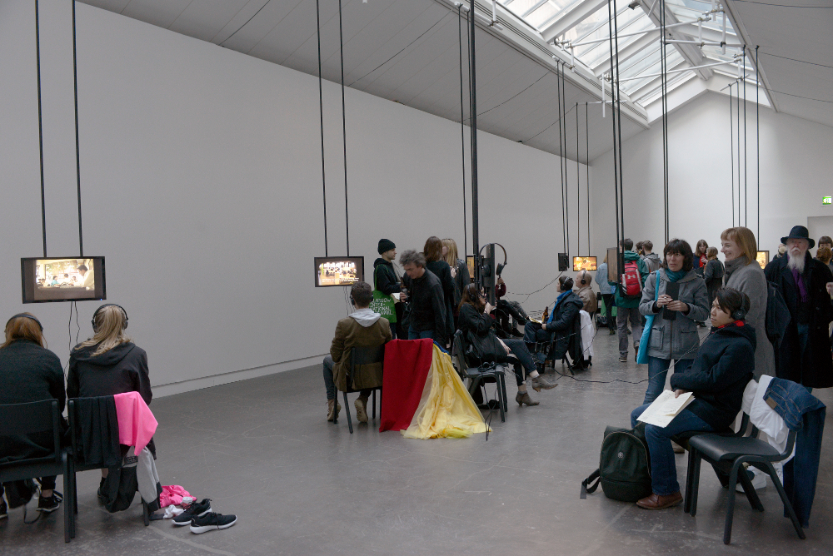
The largest Gallery space, during Pilvi Takala’s Glasgow International 2016 Exhibition

- A large print gallery map and exhibition text is available from the Box Office in the main foyer on the ground floor, and in the gallery space. You are welcome to take this into the exhibition.

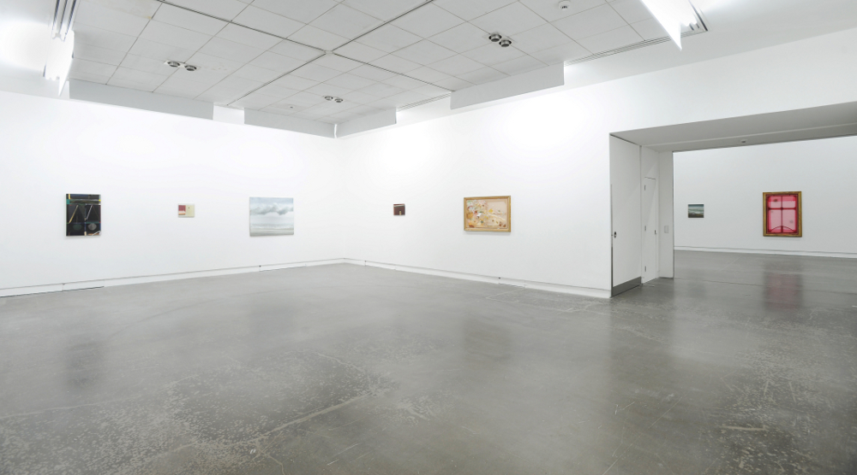Second largest Gallery space, during Merlin James’ Long Game, 2016

- The gallery has two entrances. The entrance used depends on the exhibition, but one set of doors will always be in use. The first set of doors (next to the main stairs) measure 110cm / 43.5 inches in width (one door). When both doors are open this measures 218cm / 86 inches in width. The second set of doors (by the cinema) measure 125cm / 49 inches in width.

- The Gallery is accessible by wheelchair, but please note there is a lip on the threshold of the entrance.

- There is a narrow corridor connecting the largest space within the gallery to the smallest gallery space; this measures 80cm / 31.5 inches.

- Front of House staff will be seated in the gallery throughout opening times, you are very welcome to approach a member of Gallery staff if you require any assistance or information.

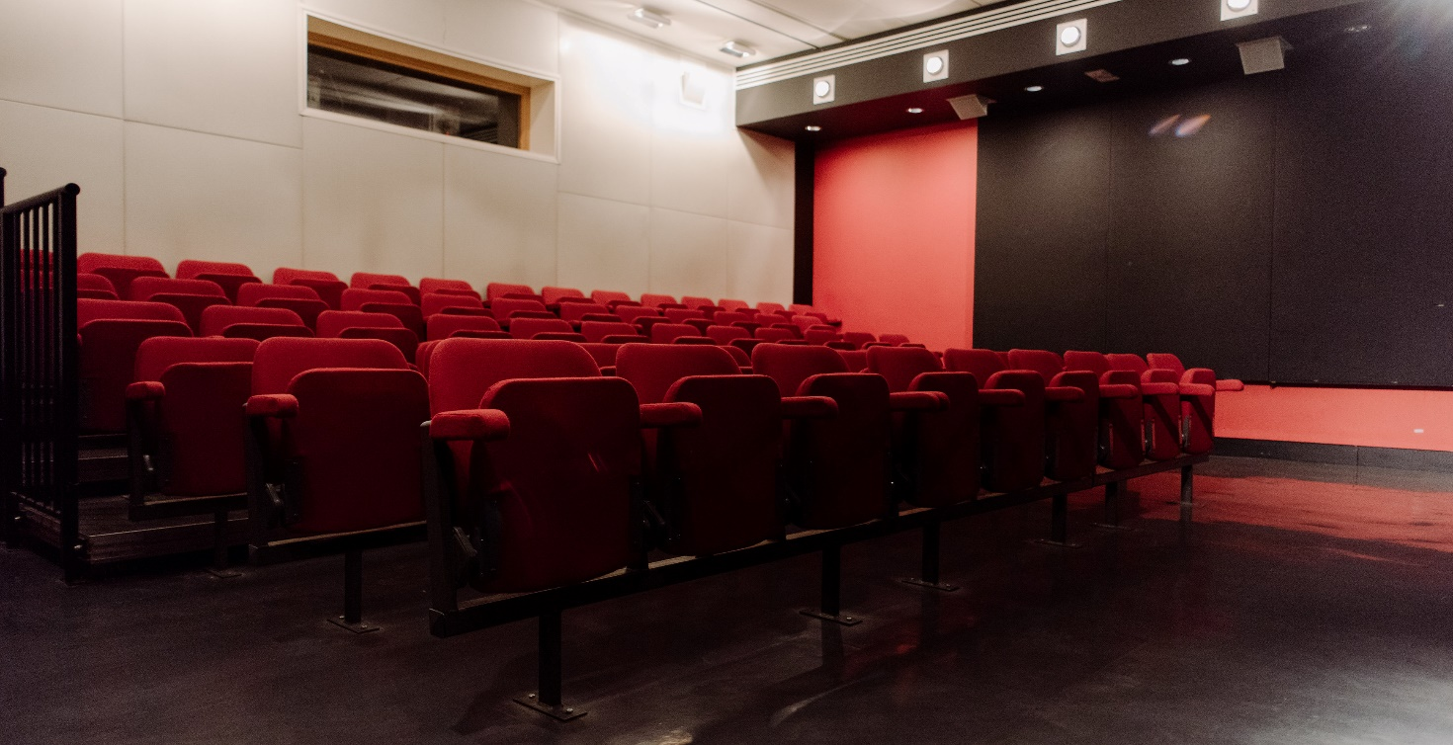Cinema (entrance to right of photo).

- The Cinema is on a level access floor with two doors. The first door is a sliding door which is 117cm / 46 inches wide, the interior cinema door is 90cm / 35.5 inches wide and opens outwards towards the cafe.

- The cinema has raked seating, with removable seats for wheelchair spaces.
Additional seats, up to a full row, can be removed from the Cinema to create wheelchair spaces, with advance notice. There is one step for each row of seating, each 15cm / 5.8 inches in height, with the front rows at ground level.

- There is a hearing loop in the Cinema. The best area for receiving this is in the centre of the seating rows. The hearing loop is connected to the audio feed for the film, and for presentations using a microphone.

- Some film screenings have English subtitles. Please check event listings on the CCA website for details – www.cca-glasgow.com.

- If we have flash or strobe lighting during any performance in CCA, there will be notices on display in the venue. Where we know about flash or strobe lighting in advance, this will also be noted on the event listing on the CCA website.

- Advanced booking is possible for ticketed events in the cinema. You can let us know of access requirements in advance, or on arrival.
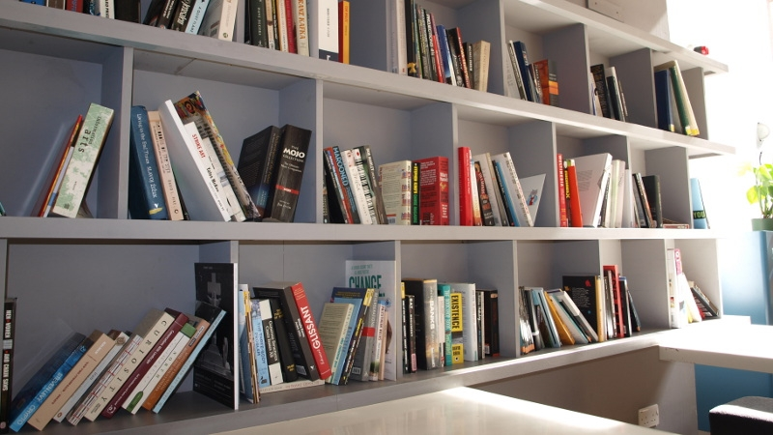
Reading Library, CCA Foyer

- The Reading Library is situated above the seating area in the foyer. It is spread over three shelves.

- The shelf heights are 79cm / 31 inches, 118cm / 46½ inches, and 156cm / 61½ inches.

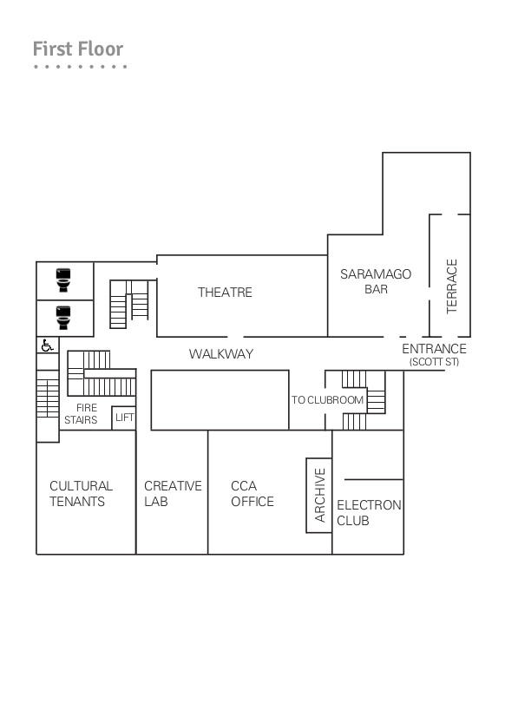
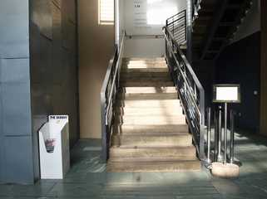
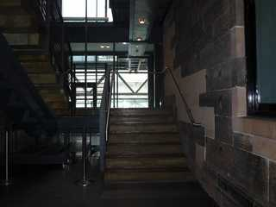
Stairwell from Ground Floor Stairwell from First Floor

- The first floor has the Theatre, Creative Lab and the Terrace Bar. It is accessible from the ground floor via the lift, or via stairs (30 steps in total).

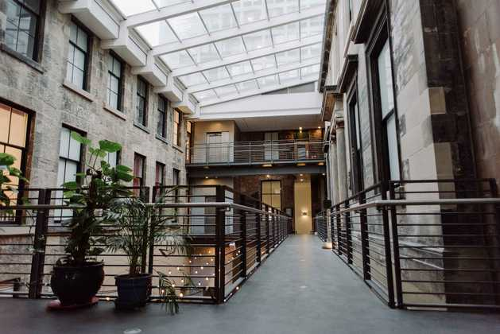
First Floor Walkway – stairs and lifts at back of image

- The corridors on the first and second floors are level and measure 147cm / 58 inches in width, with handrails throughout.
- There is level access throughout the first floor.
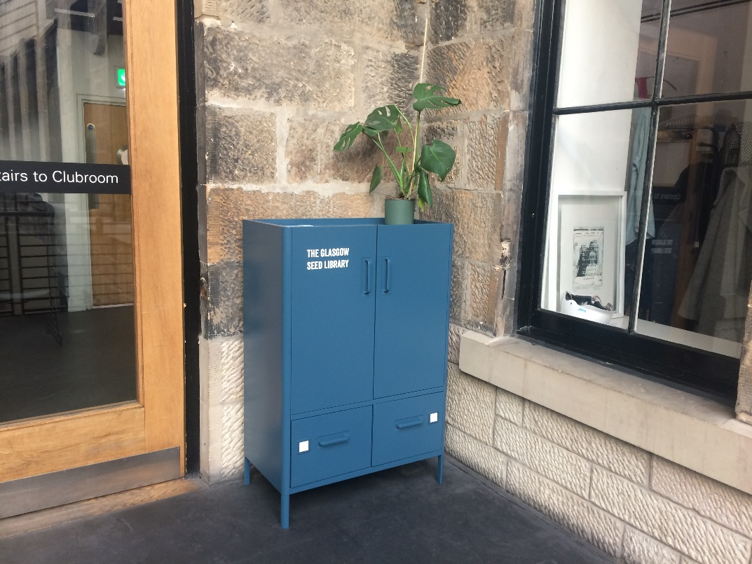
Glasgow Seed Library on the First Floor

- The Seed Library is based in a cupboard (118cm / 46½ inches high)

- The Seed Library is currently moving location, its final location is currently pending.

- The cupboard has three shelves, and two deep drawers underneath.

- Please ask a member of staff if you require assistance.

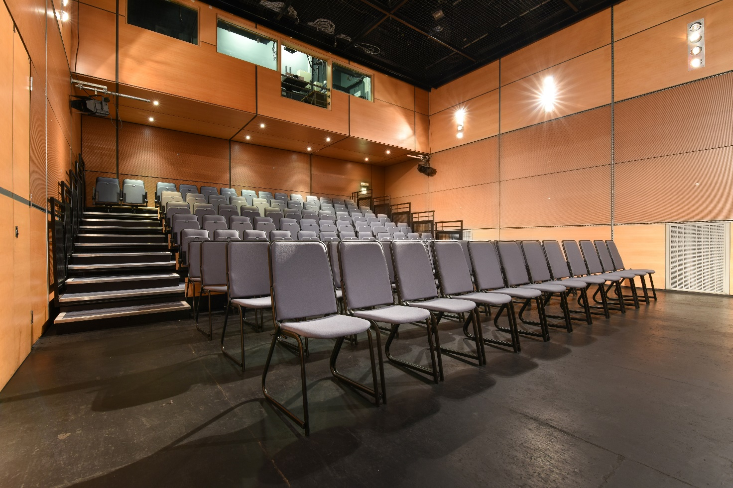Theatre (entrances on left and back right)

- There is no permanent hearing loop available in the Theatre. A hearing loop may be available where requested by our programme partners; please see our website for event details.

- The theatre has an audio description system available via headsets. This is used when our programme partners provide audio description for an event. Please see our website for event details. Our front of house staff will advise on the best seats for accessing the audio description system.

- The Theatre doors from the main walkway are 80cm / 31.5 inches wide. For some events, audience members will be asked to enter/exit via the doors to the back right. There is a flat flooring throughout; during events these doors will be staffed. The doors at the back entrance are 80cm / 31.5 inches wide.

- The seating bank in the theatre has one step per row, each 15cm / 5.8 inches in height. Removable chairs are in place in the theatre, which enable us to accommodate wheelchairs of any size.

- You can let us know of access requirements in advance, or on arrival.

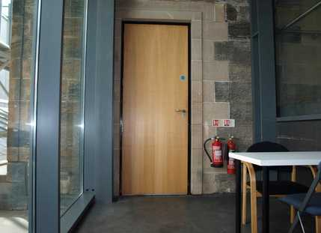
Back entrance to theatre

- The Electron Club is accessed from a corridor at the foot of the Clubroom stairs; the first door measures 86cm / 34 inches. The corridor is 104cm / 41 inches wide. The second door measures 88cm / 34.5inches and is secure buzzer entry. The buzzer is 140cm / 55 inches from the floor. The main Electron Club door is 79cm / 31 inches in width.

- The CCA archive room is located next to the Electron Club; the doorway measures 79cm / 31 inches.

- The Creative Lab is an artist residency space. It is occasionally open to public access, please ask CCA staff on arrival if you would like to visit the Creative Lab.

- Artists working in the space sometimes present their work to the public in an event (Q&A, screening, viewing). When there is an event in the Creative Lab, it will be listed on the CCA website.

- The Creative Lab door is 95cm / 37.5 inches and there are flat floors throughout the space.

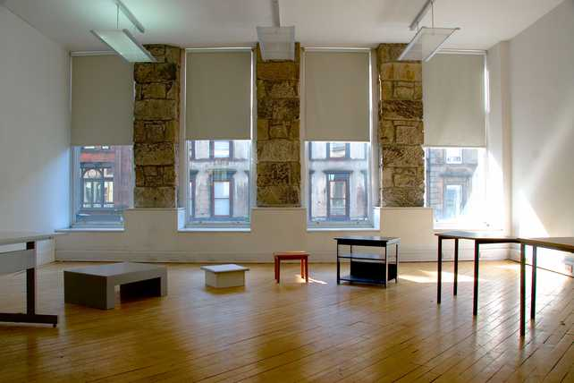
Creative Lab
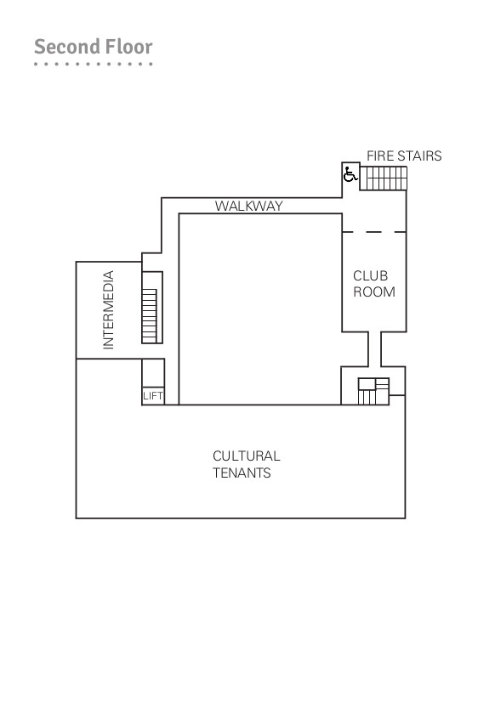
- The second floor contains the Intermedia Gallery, the Clubroom and offices. It is accessible by stairs (23 in total from the first floor) or the lift.

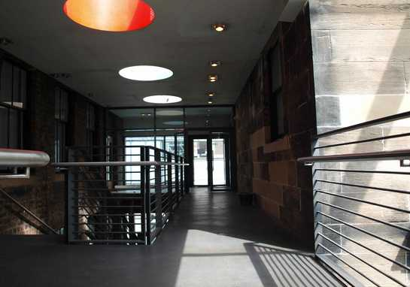
Second floor walkway

- The Intermedia Gallery has doors measuring 90cm / 35.5 inches wide, which will be open during an exhibition. All exhibitions in Intermedia Gallery will be attended by an invigilator who can provide assistance as requested.
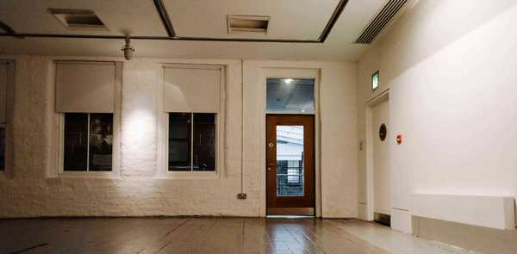

Intermedia Gallery
- The Clubroom is accessible from the second floor lift entrance along a
level corridor. Please note that there are three sets of heavy doors along this corridor. The first two doors open inwards and measure 122cm / 48 inches wide when both are opened. The third door opens outwards and measures 70cm / 27.5 inches wide. The final set of doors to the Clubroom is a double door opening inwards which measures 129cm / 50.5 inches in width. Most Clubroom events will be attended by the event organiser, otherwise CCA staff can provide assistance.

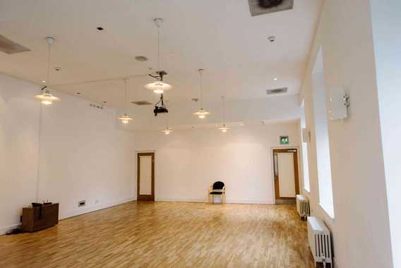
- Please note there is no hearing loop in the Clubroom.
Clubroom

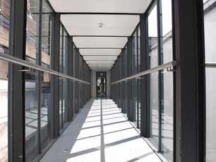
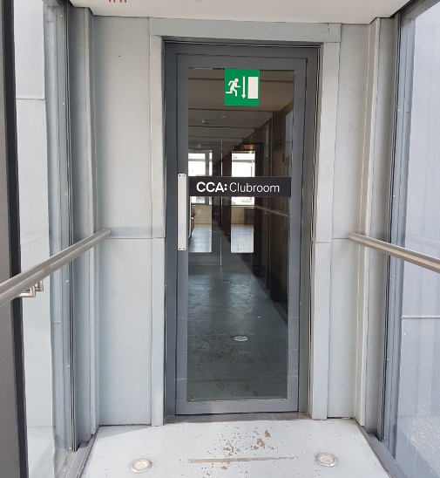
Clubroom access: corridor (L) and doorway (R)
CCA Toilets

- There are public toilets located on the ground, first and second floor.

- There are gender neutral toilets located on the first floor – one with urinals and closed stalls; and one with closed stalls only – both of which anyone is welcome to use.

- Sanitary bins are provided in all toilets throughout the building.

- We are a period friendly venue with period friendly points located in all of our toilet facilities. Period friendly points are specific locations where people experiencing homelessness can access free sanitary and other products to use. Here you can find free tampons, sanitary towels, spare pants, wipes and disposable bags. Our period friendly points are provided by Simon Community Scotland.

- There are two individual unisex accessible toilet cubicles on the ground floor, with level access and handrails, located at the rear of the Cafe Bar. The doors on both are 84cm / 33 inches wide. The transfer space is to the left hand side and measures 147cm / 58 inches in width and 93cm / 36.5 inches in depth.

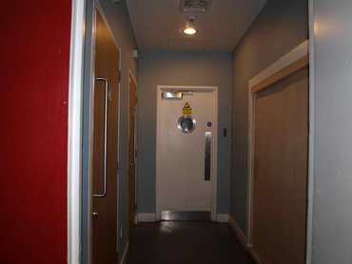
Corridor for ground floor accessible toilets – entrance by bar

- Please note that while both ground floor toilets are accessible, the second toilet is more easily accessible due to the distance from the corridor door.

- There is a baby change facility located in the first of the two unisex toilets on the ground floor and in the accessible toilet on the first floor.
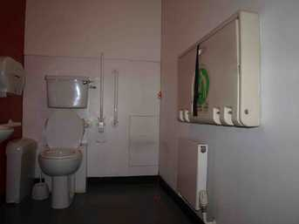
Accessible toilet with baby change facility on ground floor.
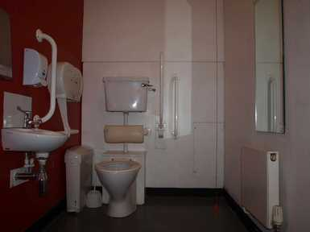
Accessible toilet on ground floor.

- Automated hand dryers are installed in each of the accessible cubicles.

- On the first floor, there is a unisex accessible toilet with handrails and a left hand side transfer space measuring 102cm / 40 inches wide. The door is 85cm / 33.5 inches wide.

- All the toilets have non-slip vinyl flooring.

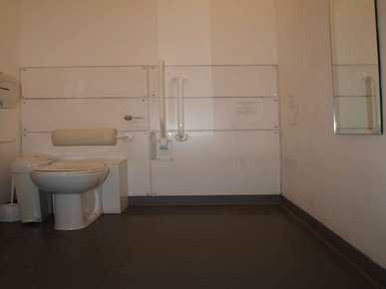
Accessible toilet on first floor

- There are handrails in all four accessible toilets and all toilets are 47cm / 18.5 inches in height.

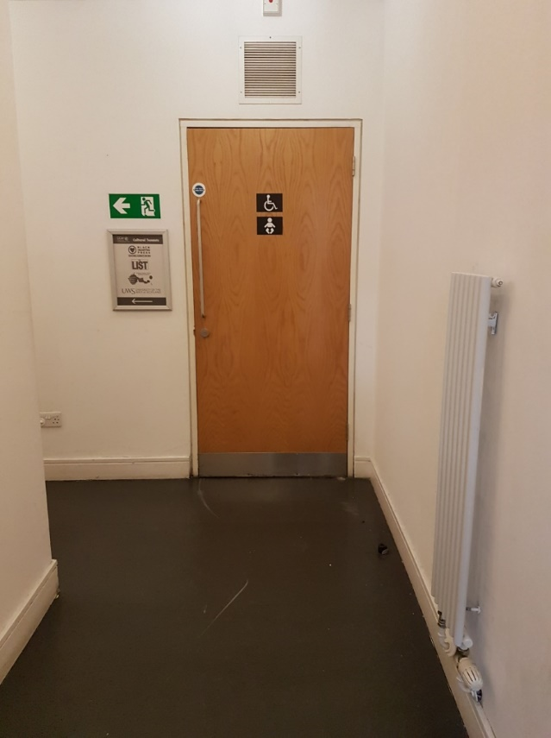
Corridor entry for first floor accessible toilet

- On the second floor, there is a unisex toilet with handrails but no side transfer. The door is 84cm / 33 inches wide and there is a turning space measuring 147cm / 58 inches (wide) by 93cm / 36.5inches (deep).
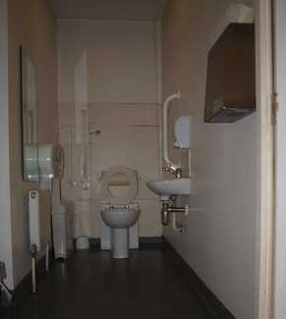
Accessible toilet on second floor

- Each accessible toilet has an alarm cord for any users who experience difficulties. This is linked to our intruder alarm system, which notifies the Duty Manager of any activation. The Duty Manager will attend to these activations immediately.
Saramago Café Bar & Terrace Bar

- Saramago Café Bar is located on the ground floor between the CCA foyer and gallery, with step free level access from both.

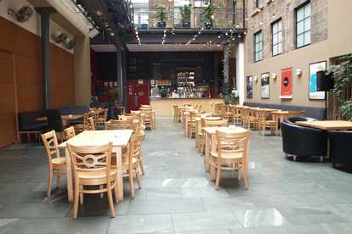
Saramago Cafe Bar

- Tables in the cafe bar are spaced to leave a corridor which measures 94cm / 37 inches approx in width. There is additional space at tables located at the end of the cafe area.

- Lighting is a mix of natural daylight and overhead bulbs. On occasion, there are red theatre lights in use; these can be turned off if we have advance notice of requirements.

- There is background music in both Saramago Café Bar and Saramago Terrace Bar during the day, and DJs play in the Terrace Bar in the evenings at weekends.

- Highchairs are available on request. There are five in total.

- The tables and chairs in Saramago Cafe Bar are not fixed or bolted to the floor. There is some fixed seating around the edges of the Cafe Bar, but the majority of furniture is movable.

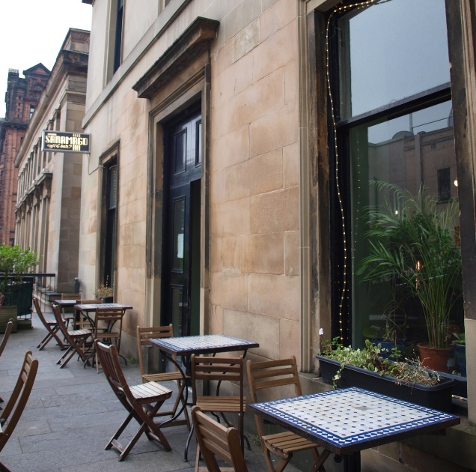
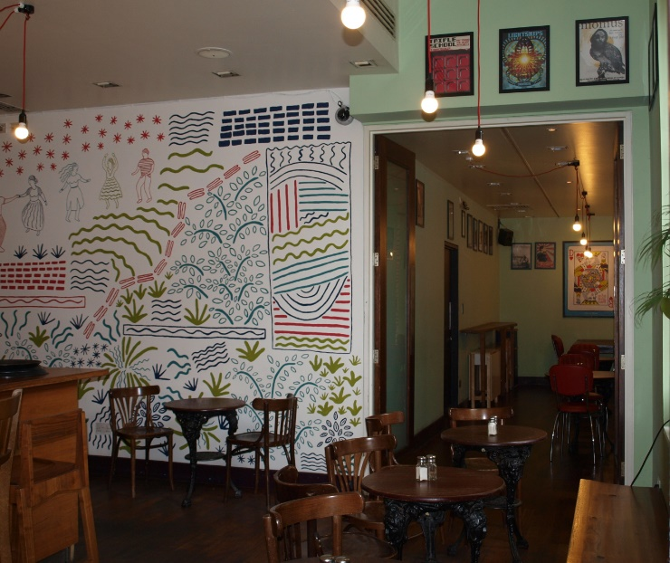
Saramago Terrace Bar Saramago Terrace Bar outdoor seating

- Saramago Terrace Bar is located on the first floor, beside Scott Street.

- There are eight stairs with a handrail leading from Scott Street to the entrance. Please note that Scott Street is a steep hill. For level access to Saramago Terrace Bar, please use the Sauchiehall Street entrance and take the lift from the ground floor to the first floor. The Terrace Bar is then accessible from the other end of the first floor along a level corridor.

- There is a mix of indoor and outdoor seating in the Terrace Bar. There is some fixed bench seating in the Terrace Bar, but the majority of tables and chairs are not fixed to the floor.

- Table service is available if required; please speak to a member of staff on arrival.

- There is no lowered counter access at either bar. Please let Saramago staff know of any requirements.

- A large print menu is available on request in Saramago Cafe Bar and Saramago Terrace Bar, as well as from Box Office on the ground floor.

- If you have any allergy queries, please ask a member of staff.

- For table bookings, please call Saramago on 0141 352 4920. Wheelchair requirements and highchairs can be requested in advance.
Shops: Welcome Home & Aye-Aye Books

- Two shops are located in the ground floor foyer area of CCA at the Sauchiehall Street entrance.

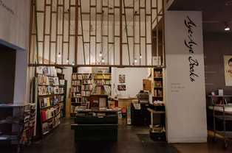
- Aye-Aye Books stocks a range of books and Welcome Home is a design and craft shop.
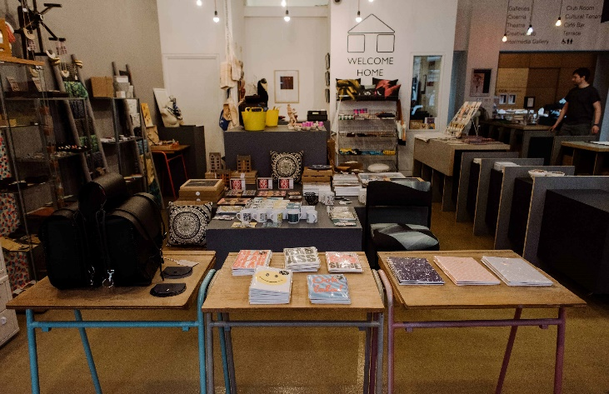
Aye-Aye Books and Welcome Home

- The shops are in the open-plan foyer area and there are no doors from the foyer to the shops.

- The shops are staffed during opening hours; staff are on hand to offer advice on products and access to items on higher shelves and inside cabinets. There are also low shelves which are accessible from a seated position.

- Stock changes regularly, for up-to-date prices please ask a member of staff.

- Both Aye-Aye Books and Welcome Home have high service counters, but there is a low level counter at both sides of the CCA main box office desk which is situated between the two shops. There are level floors between the low-level counter and the two shops.

- A hearing loop is available at the CCA main box office desk.

Additional Information

- Our staff receive regular training including Disability Awareness Training and the Visit Scotland Accessible Tourism Customer Service Training.

- Front-of-house staff and duty managers are trained by Epilepsy Scotland to recognise the signs of someone experiencing a seizure and to assist someone who is or has experienced a seizure. We have a soft floor mat available if anyone needs to lie down quickly. This training will be repeated on an annual basis.
- We have foot stools available for visitors needing them for use in the Theatre, Cinema or any other event space.

- A venue map of CCA is available in the foyer. A PDF version is available online: cca-glasgow.com/about-cca/cca-venue-map

- We have a set of evacuation procedures. In the case of an evacuation, staff will provide instructions and discuss the evacuation options available.

- A large print version of the CCA brochure is available at box office and large print menus are available in Saramago and at box office.

- We welcome trained assistance dogs. A water bowl is available on request. Non-working dogs are only permitted in the Terrace Bar and main foyer. Guide dogs are allowed throughout the building, with their owner.

- We offer informal introductions and tours to blind and partially-sighted visitors. For details, please email boxoffice@cca-glasgow.com in advance

- There are high-contrast (white text on a black background) directional signs in the foyer, stairwells, lift guide, room entrances and doors.

- There are various power points in the foyer which (availability permitting) can be used to charge mobility scooters.

- Duty Managers have first aid training, please ask for assistance if required.

Future Plans

- We are continually working to make improvements to our accessibility.

- Nosing will be installed on our stairs.

- We are hoping to improve the doors, particularly in the second floor corridor and main entrance, and hope to also install a hearing loop in the Theatre.

- We're open to feedback and welcome ideas on how we can improve. Please email boxoffice@cca-glasgow.com with comments.

